**DAILY ONLINE ACTIVITIES SUMMARY**

|  |  |  |  |  |  |  |  |  |
| --- | --- | --- | --- | --- | --- | --- | --- | --- |
| **Date:** | **19-06-2020** | | | | | **Name:** | **Sinchana** | |
| **Sem & Sec** | **6 B** | | | | | **USN:** | **4AL17CS117** | |
| **Online Test Summary** | | | | | | | | |
| **Subject** | | **C programming and python workshop** | | | | | | |
| **Max. Marks** | |  | | **Score** | | |  | |
| **Certification Course Summary** | | | | | | | | |
| **Course** | **Programming in C** Workshop on Applications of Python Programming in Data Analytics and Machine Learning | | | | | | | |
| **Certificate Provider** | | | **Miss.Shilpa**  **Dr.Badhusha** | | **Duration** | | | **4 hrs** |
| **Coding Challenges** | | | | | | | | |
| **Problem Statement: 1.dll reverse order**  **3.** **Python Programming in Data Analytics and Machine Learning exercise.** | | | | | | | | |
| **Status: Success** | | | | | | | | |
| **Uploaded the report in Github** | | | | | **Yes** | | | |
| **If yes Repository name** | | | | | **coding**  **Python_Programming_in_DA_and_ML** | | | |
| **Uploaded the report in slack** | | | | | **Yes** | | | |

Online Test Details: (Attach the snapshot and briefly write the report for the same)

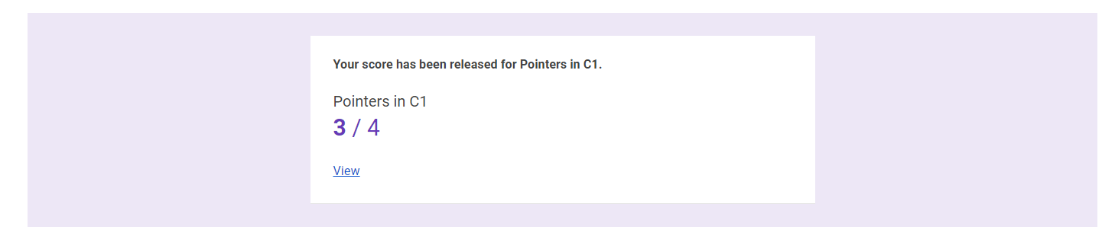

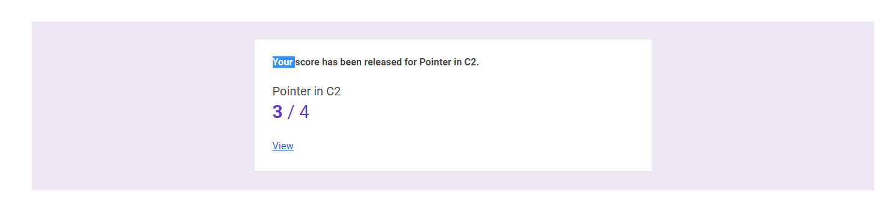

This is the response c programming test and this is the snapshot of this.

Certification Course Details: (Attach the snapshot and briefly write the report for the same)

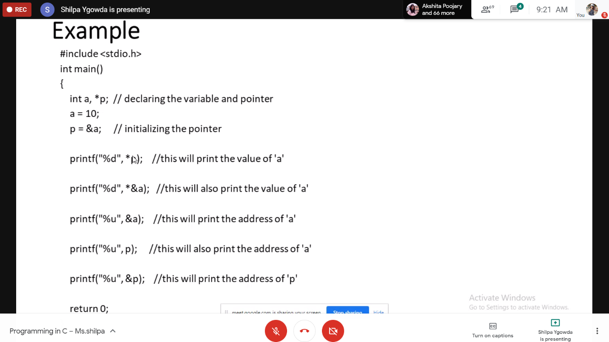

Today I have learnt about basics of c programming in which I was thought about pointers in c.

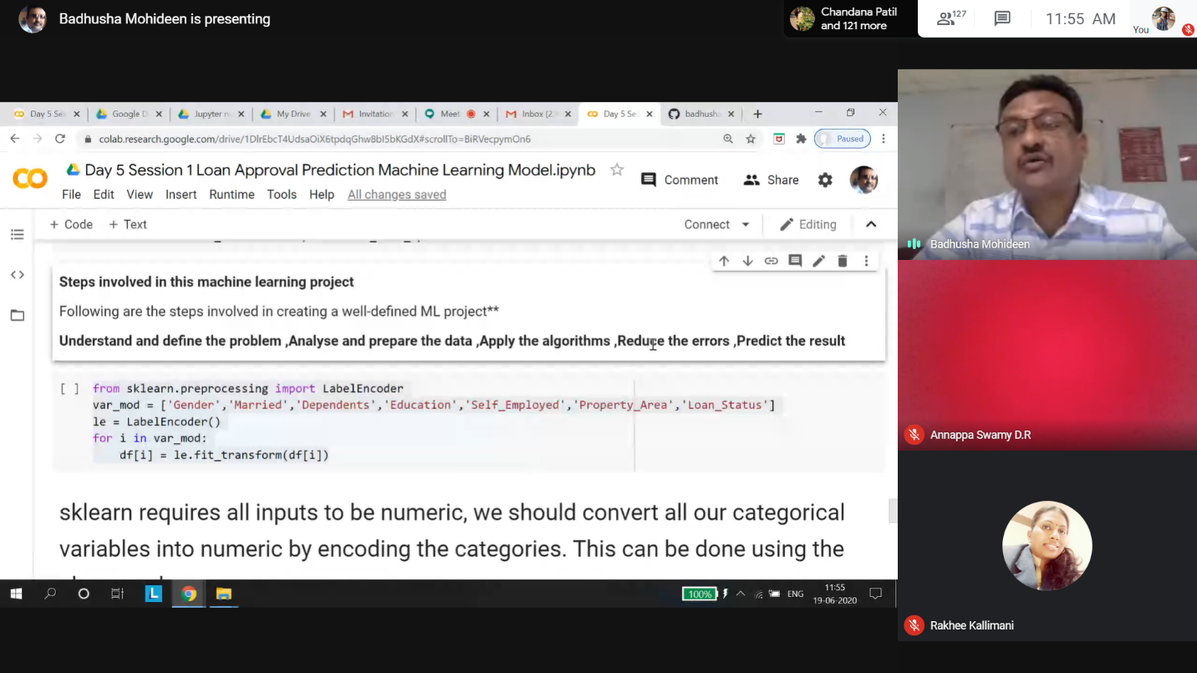

Today I have learnt about DL Model and hand on hand examples where explained.

Coding Challenges Details: (Attach the snapshot and briefly write the report for the same)

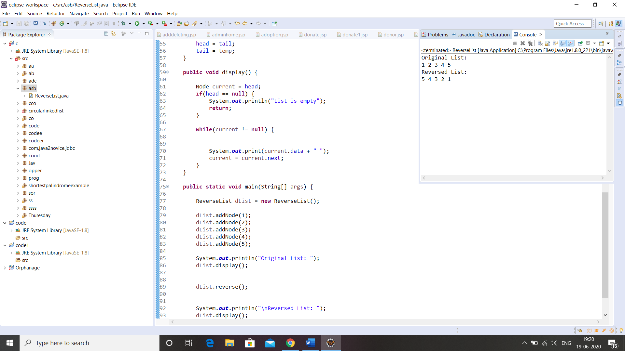

Link in Github :

1. Python Programming in DA and ML Workshop exercise

[<https://github.com/sinchana514/Python_Programming_in_DA_and_ML>L](https://github.com/sinchana514/Python_Programming_in_DA_and_ML)

1. Coding and Word document

<https://github.com/sinchana514/coding/tree/master/16th%20june>